

Build
User Guide

Prepared by: Rapid Solutions and Consulting LLC
Last Updated: October 21, 2016

Table of Contents
1. Introduction 3
2. Using BUILD 4
6. HTML injections – installation steps 18
7. Injection into Oracle EBS with a custom character set 19
8. Substitution tokens in the BWE file 20
9. Appendix A: Troubleshooting 21
10. Further Reading 28

1. Introduction

RapidBuild (Build) is a tool part of the Rapid client suite used to automate the setup of Oracle Applications configurations using the Oracle Forms playback and HTML technology to inject configurations. It is a desktop application written in JAVA which will commnicate with your EBS oracle instance.

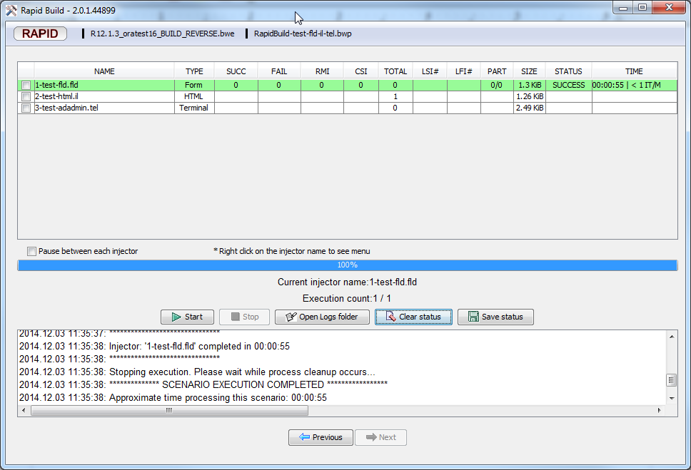

2. Using BUILD
This section explains how to use Build to inject into an existing Oracle EBS Instance step by step. Before running the injection, you must have both the BWP and BWE files. Launch Build by double clicking on its icon located on your Desktop:


- Environment Validation:
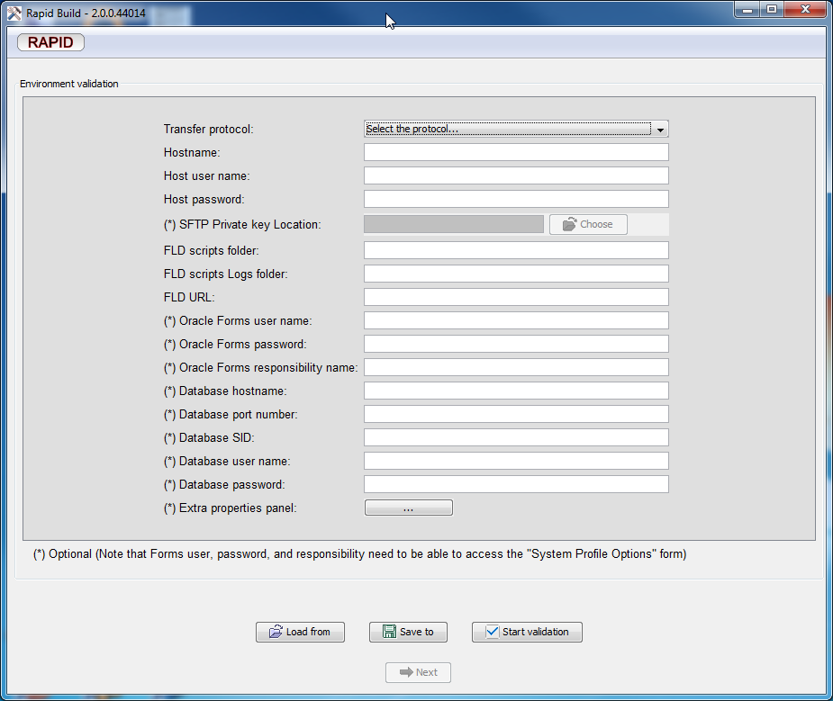

This screen will ask you to setup a Build Environment and save it as a file (.BWE is the file’s extension) from either local drive or network drive where you place it on. That file contains all information related to the connection to the target server (IP address, port number, FTP setups, etc.) that is necessary prior to running the injectors. Build will not allow you to go further until the information has been validated.
Note That the unpacked distribution contains sample Environment files for Oracle Release R11and R12, you can use those as a template:

environmentTemplate_R11.rapidbuild
environmentTemplate_R12.rapidbuild

For the first time, load the corresponding template on the first screen and change the parameters accordingly.

If you have been supplied with an Environment / BWP pair of files by your implementation partner, you should be sure to select the correct files and not use the default.
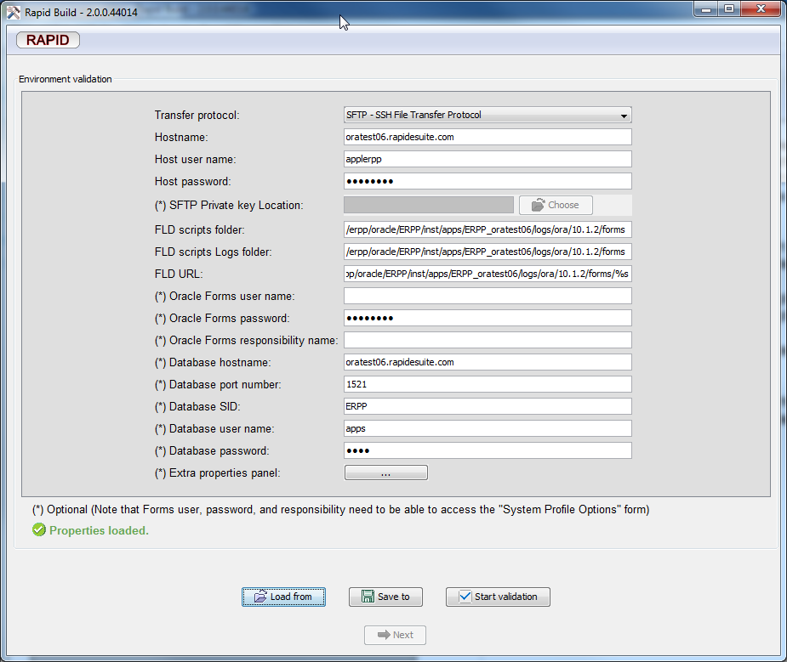

“Load From” and “Save To” buttons are available if you wish to modify any fields and load/ save from a file.

Here is a complete reference of each parameter and what needs to be keyed. Consult your System Administrator for any parameters you are unfamiliar with.

- Transfer Protocol
It contains the protocol necessary for a connection to be established with the Oracle EBS instance in order to transfer the injection scripts. The possible values are:
- “SFTP - SSH File Transfer Protocol”: for a secure connection – recommended in most cases.
- “SFTP with private key file”: same as SFTP but requires a file which contains the password – this is recommended for government type EBS instances or OOD (Oracle on Demand)
- “FTP – File Transfer Protocol”: for an unsecured connection to the EBS instance. Recommended only for testing purposes.
- “Local Filesystem Folder”: some EBS are configured such as it is forbidden to access their filesystem directly (no SSH server installed) – so this option can be used to copy the scripts to a local folder on the client then the customer program can use this to automatically copy them on the EBS instance using their preferred choice.
- Hostname
It contains the hostname to access the Oracle EBS forms server. Example: oratest16.rapidesuite.com

- Host user name
It contains the login necessary for a connection to be established in order to transfer the injection scripts. This needs to be an account on the Unix/ Linux remote host that has the ability to create and delete files in the path specified in the property FLD script folder. Example: Applerpp

- Host password
It contains the password necessary for a connection to be established in order to transfer the injection scripts. Example: Applerpp

- SFTP Private key location
It contains the location of the file where the private key resides for a SFTP connection to be established in order to transfer the scripts. Only required if the transfer protocol is “SFTP with private key file”.

- FLD scripts folder
It contains the location where the injectors will be transferred to on the Oracle application server. Make sure that the value in “FLD scripts folder” is also specified in the “FLD URL” parameter otherwise the injection will stop at the login page (Oracle will not be able to find the script).
This folder MUST be the folder specified in the XML file pointed to by the $CONTEXT_FILE variable.
This path MUST be read/write for the user named in Host user name in order for Build to be able to upload/delete/download files.

Example: CONTEXT_FILE=/data/erpp/erppappl/admin/ERPP_orrsctst10.xml

R12: <forms_trace_dir_oa_var="s_forms_trace_dir">/erpp/oracle/ERPP/inst/apps/ERPP_oratest19/logs/ora/10.1.2/forms</forms_trace_dir>
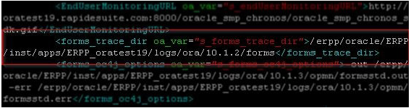
R11:
<forms_trace_path oa_var="s_forms_trace_path">/erpp/scripts</forms_trace_path>

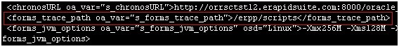
- FLD scripts Logs folder
- It contains the location where the injectors FLD log files produced by the Oracle EBS instance are generated during the injection process.Those are essential when troubleshooting injections errors.
- FLD URL:
- It contains the full URL required to inject the scripts. You will need to update it and change the host/port and folder parameters. Seemingly innocuous changes to the format of this URL can sometimes result in failure. Please follow the exact format:
R12.X: http://servername:port/forms/frmservlet?record=%s.log%20play=%s
R11.5.10: http://servername:port/dev60cgi/f60cgi?record=%s.log%20play=%s
Occasionally, substituting the ampersand character “&” for %20 will fix a non-functioning injection. The %20 format is to be attempted first:
R12.X: http://servername:port/forms/frmservlet?record=%s.log&play=%s
R11.5.10: http://servername:port/dev60cgi/f60cgi?record=%s.log&play=%s

- Oracle Forms user name
It contains the Oracle user name necessary to connect to Oracle Application forms.
It can be any valid Oracle user name who can login the the Oracle portal page.

- Oracle Forms password
It contains the password for the above Oracle user.

- Oracle Forms responsibility name
It contains the EBS responsibility name, which has access to the “System Profile” form. It will be used to enable Checkboxes at execution time for each of the Oracle user specified in the scripts. So, every Oracle user in the BWP must have access to that responsibility.

- Database hostname
It contains the hostname to connect to the EBS database.

- Database port number
It contains the port number to connect to the EBS database. Example: 1521

- Database SID
It contains the SID to connect to the EBS database. Example: ERPP

- Database user name
It contains the user name to connect to the EBS database. Example: APPS

- Database password
It contains the password for the Database user name.

- Extra properties panel
Extra properties (example: replacement tokens) can be entered via that window. It is useful if you need to protect your passwords in the RapidConfigurator table “RSC – Responsibilities module mapping table”. Please see section “Substitution tokens in the BWE file” for more details.

Click on the “Start validation” button when all the parameters have been keyed in. This will start Oracle Forms in order to test that Oracle Forms playback is enabled and properly configured.
Click the “Next” button when you are finished validating the configuration changes.
See below screenshot for a validated BWE.

- Single Sign On
This screen is for the user to enter Single Sign On environment variables. It is essentially an extension of the environment validation screen. The values in the screen can be saved to or loaded from a *.bwe file, like the values in the environment validation screen.

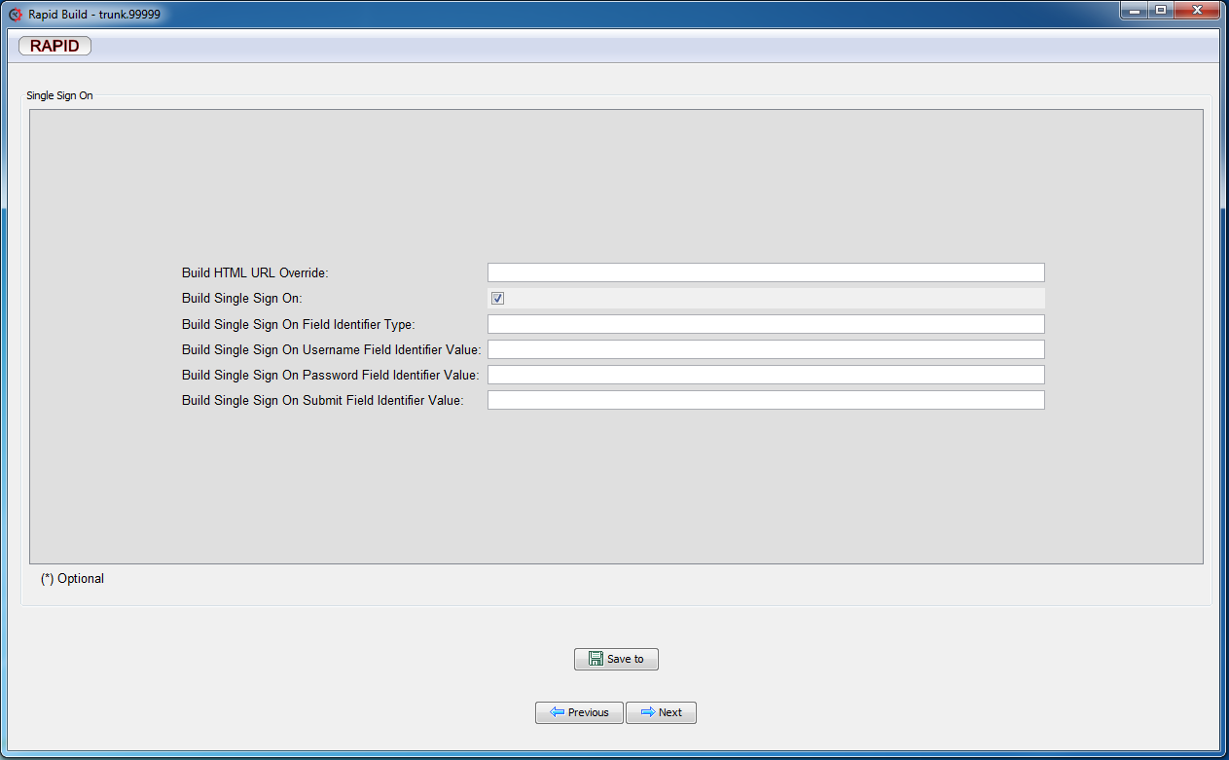
You only have to specify those values if you intend to use the SSO feature. Please read the “Rapid E-Suite Build - Single Sign-On setup” document for further information about the SSO feature.
- Injectors Package Selection

This screen will ask you to select a Build Package file (.BWP is the file’s extension) from either local drive or network drive where you place it on. A BWP file contains all the injectors to be applied to an Oracle Application Instance. Examples of injectors are Playback files (FLD used to build an instance), HTML pages to display manual steps to be done, Linux scripts, adadmin, adpatch activities, etc. The Build will not allow you to go further if the selected file is not a BWP file or if the format is not recognized (e.g., corrupted file, etc.).

As you can see below, the content of the selected package will be displayed for your information. Click the “Next” button as nothing special is required after selecting the file.

Note that this screen is optional so you can click “Next” anytime to continue to the Injection screen. However, note that the injection may fail with the following error, in this case you will need to enable the checkboxes as per the above.

- Injectors execution

At this screen, you can select all or some of the injectors to be run and click the “Start” button when you are ready to inject your new configurations or apply configuration changes or apply patches.

The selected injectors will be run in order and without delay between scipts (you can always change this behavior by checking the box “Pause between each injector”). Users can also stop the execution when appropriate by clicking on the “Stop” button.
Once an injector is completed, the check box will be unchecked and the next injector in the sequence will be executed until every injector is run.
After you finish running Build, you can access your EBS instance to check on your configurations.

Right clicking on any injector row will give you access to a menu where you can select a particular iteration or view the script file/ log file or check/ uncheck injectors below/ above.

Iteration selection allows you to start (or restart) an injection at a specific record. This is particularly useful after an injection has failed due to data issues and you regenerated a new BWP.
You can right-Click on any iterations and a menu will provide you options to mass select/ deselect iterations or even view injections logs for specific iterations.

If you encounter this error while injecting FLD scripts, then it means that you are trying to log in to the Oracle EBS instance with an invalid oracle user, RapidBuild will not allow you to proceed until you create the Oracle user in the instance.

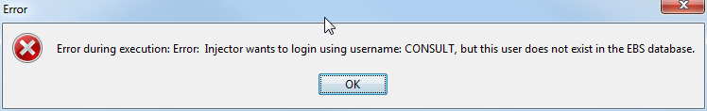
- Oracle Forms Checkboxes Validation screen
RapidBuild will check that the Oracle user, whom you are using in the injectors, is configured properly for injection. If not, you will see this screen when injecting:

This screen is used to enable some Oracle configurations required for the Oracle users needed to perform the injections. It means that the Oracle user exists in the EBS instance but the configurations are not setup yet. This step is automatic.
RapidBuild will start an extra injector to setup the Oracle user. However, you may see the error below if you didn't setup properly the parameter: “Oracle Forms responsibility name” (see section 4. Using BUILD)
It means that the Responsibility you set up does not have access to the “System Profile” form. You will need to correct your BWE with a valid Responsibility or correct your Responsibility in Oracle EBS to add that “System Profile” form.

Then try again to “Enable for Injection”. It should proceed until completion then the popup window will close automatically.

6. HTML injections – installation steps
Please refer to the document for the installation steps prior injecting using the Oracle HTML pages:

Rapid Build - HTML injections prerequisites.pdf

7. Injection into Oracle EBS with a custom character set
This is useful is your EBS instance is not UTF-8 and that you need to inject non-ascii characters. You will need to add the following property to your BWE using the extra property screen on the BWE validation screen: CHARACTER_SET then set the value to the correct character set as per your Oracle EBS instance that you want to inject to.

Example: DB character set: select * from nls_database_parameters;
=> WE8ISO8859P1 then add an extra property Cp284 (see screenshot below)

Cp037 | USA, Canada, Netherlands, Portugal, Brazil, Australia
Cp273 | Austria, Germany
Cp277 | Denmark, Norway
Cp278 | Finland, Sweden
Cp280 | Italy
Cp284 | Catalan/Spain, Spanish Latin America
Cp285 | United Kingdom, Ireland
Cp297 | France
Cp420 | Arabia
Cp424 | Hebrew
Cp871 | Iceland
Cp874 | Thai
Cp875 | Greek
Cp930 | Japanese
Cp933 | Korean
CP935 | Simplified Chinese
CP937 | Traditional Chinese

8. Substitution tokens in the BWE file

You can use this feature to hide sensitive information (like passwords).
If you define a parameter starting and ending with ### then that value will be replaced at injection time by the value of the property keyed in the BWE screen.

Example: in the RSC table: “RSC – Responsibilities – Module Mapping”, you can define
the value in the Password column: ###ORACLE_SYSADMIN_PASSWORD###

Then, the FLD script will be generated as follow:

VALUE FNDSCSGN SIGNON PASSWORD 1 ###XXSYS_LOGIN_PASSWORD###

Then, what you need is to enter the following property in the BWE screen:

###XXSYS_LOGIN_PASSWORD### in the column “Property Name” and the real password in the column “Property Value”. See screenshot below. Close the “Extra properties” window in order to save your changes.

9. Appendix A: Troubleshooting
This section describes the most common issues with Build and their resolutions.

- Injections failure troubleshooting:

Please check that the data you are trying to inject is correct – the best way is to try to enter manually the record in the Oracle Form and to save it, this will trigger the standard Oracle validation so there is a good chance that you will understand the root cause of the injection failure and resolution.
However, if after that you still stuck at resolving the issue, then provide the Build log files and injections log files when filling a support ticket by doing the following:

Click on the RAPID top left icon then click “open ticket” (attach the Build log file generated by this option).
Also, attach the zip file generated by “Zip Iteration Logs” if any - all the log files are located in the installation folder under “Log” then the BWP name.

Example:
C:\RES\rapidclient-2.0.0.43449\log\build\Instance_7_Segment-db01.rapidesuite.com-25253\logs

- Oracle forms not playing back the script, it stops at the Login screen.

Please make sure that you followed the steps in the document:
https://sites.google.com/a/erapidsuite.com/documents/Home/manuals/formsplayback

But if after that it still does not work, then please check the following:
The order of the parameters in the FLD URL, ie "record=" must be used and it must appear before "play=". Furthermore, these two parameters must be separated by "%20" and nothing else.

Example:
http://server.com:24604/dev60cgi/f60cgi?record=%s.log%20play=%s

- Oracle bug multi-threading/multi-processor/multi-core
In R11:
Due to a threading bug in the R11 Forms Applet (see Oracle Metalink Note: 300386.1 and Bug: 4183450), injections into an R11 server should not be performed from a multi- processor PC, as the injection will frequently encounter Oracle Forms errors. When injecting into an R11 server, be sure that the Windows installation in which you’re running Build has only one available processor – something easily confirmed by opening the Windows Task Manager, clicking on the Performance tab, and observing how many CPU graphs are displayed. (There should be only one).

In R12:

According to Oracle document ID 1245895.1, Sun JRE running on Multiple (Dual) core CPU Makes Forms Freeze. Using BUILD under the environment described in the Oracle document may be encounter Oracle forms usually hang while injecting Oracle forms technology. Please find workaround and solution in the Oracle document and to check Oracle forms version please read Oracle document ID [ID 468311.1.

Please note that the above documented bug can and does occur during normal (non-Build) use of Oracle Forms on a multi-processor/multi-core machine, but at a much lower frequency. It is due to the speed at which Build interacts with the Forms Applet that the frequency of the error increases such that it becomes problematic.

- Oracle Forms Frozen, hanging

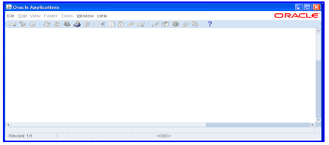

Oracle Applications has launched but does not complete, i.e. does not close itself, it hangs.
Common cause: “Diagnostics” is not enabled in Oracle Apps.
Looking at the current FLD log file, you can pinpoint which FLD command that was last executed, if it looks like:

MENU CUSTOM DIAGNOSTICS EXAMINE

USER_EXIT RESPONSE VALIDATE 2 LOC OFFICE_SITE_FLAG "N"
USER_EXIT RESPONSE OK 2 LOC OFFICE_SITE_FLAG "N"

Then you will need to enable Diagnostics in Oracle Apps or go to the “Validation checkboxes” screen in Build.

Also, ensure that your configuration of OS, Browser and Java version is certified by Oracle, many Forms frozen issues are related to incorrect configuration matrix.

- Unable to login to Oracle Apps directly to the Forms

- “APP-FND-01542: This Applications Server is not authorized to access this database. “

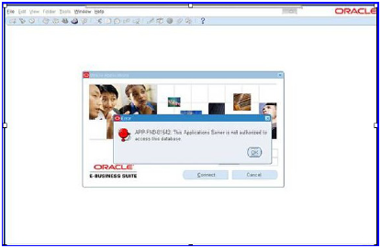
SOLUTION: Forms playback is not enabled correctly. Please follow the instructions at:
https://sites.google.com/a/erapidsuite.com/documents/Home/swiftsuite-for-the-oracle-e-business-suite/manuals/getting-started/formsplayback

2. "The Applications user, RAPID_SOLUTIONS is not authorized to access the database."

SOLUTION:
Usually, it occurs because the password of the Oracle user has expired. Please change the password then try again.

- Find your Oracle Java Runtime Environment in Window 7 and Window Vista

Click “Start” → “Control Panel”→ “Uninstall a program”, you will find installed Java.
For Window XP please click “Start” → “Control Panel”→ “Add or Remove Programs”.

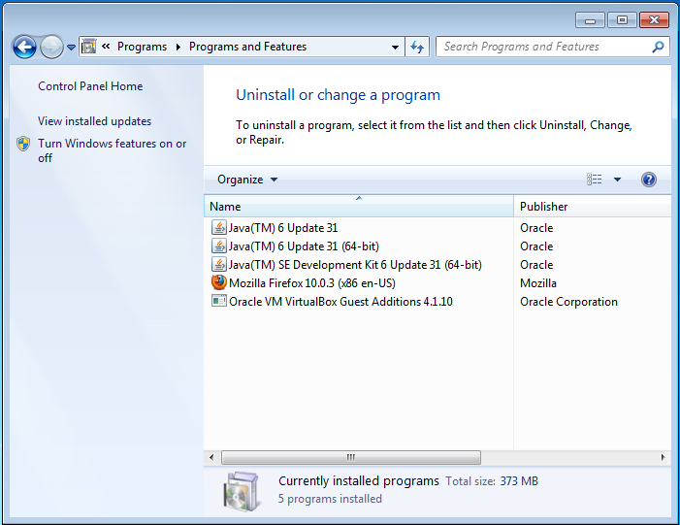

10. Further Reading

Please consult the RAPID Build Installation Guide for information on how to install and troubleshoot RAPIDBuild.

